Grade 7 Accelerated · Unit 3 · Lesson 5  Applying Exponent Laws  Independent Set 3.05 ANSWER KEY | Name  Date  Period

Six questions, on your own, in silence. Show the step that does the work.
1. Rewrite with a positive exponent. 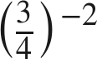
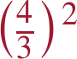

2. Find the value. 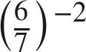

Flip, then square.

3. Rewrite with a positive exponent. 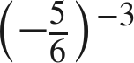
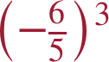
The base keeps its sign through the flip.

4. Find the value. 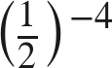
16
(2/1)⁴.

5. Find the value. 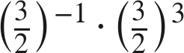
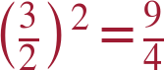
−1 + 3 = 2.

6. Find the value of . 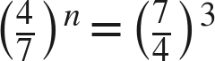
n = −3
Flipping the base flips the exponent's sign.

